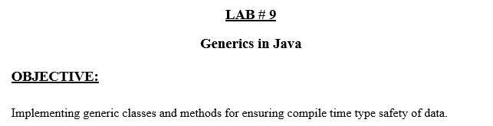

**Lab Task:**

Write a program that takes integer array, double array and character array. Make a generic function that prints these array in reverse order.

**Code:**

**import java.util.*;**

**// Generic class implementation**

**class ReverseArray {**

**// Generic method to print an array in reverse order**

**public static <T> void printReverse(T[] array) {**

**System.out.print("Reversed Array: ");**

**for (int i = array.length - 1; i >= 0; i--) {**

**System.out.print(array[i] + " ");**

**}**

**System.out.println();**

**}**

**}**

**public class Lab9Generics {**

**public static void main(String[] args) {**

**// Integer array**

**Integer[] intArray = {1, 2, 3, 4, 5};**

**System.out.println("Integer Array:");**

**ReverseArray.printReverse(intArray);**

**// Double array**

**Double[] doubleArray = {1.1, 2.2, 3.3, 4.4};**

**System.out.println("Double Array:");**

**ReverseArray.printReverse(doubleArray);**

**// Character array**

**Character[] charArray = {'A', 'B', 'C', 'D'};**

**System.out.println("Character Array:");**

**ReverseArray.printReverse(charArray);**

**}**

**}**

**Output:**

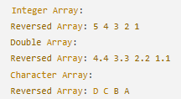

**Git hub:**